# CS 255 System Design Document Template

.

## UML Diagrams

### UML Use Case Diagram

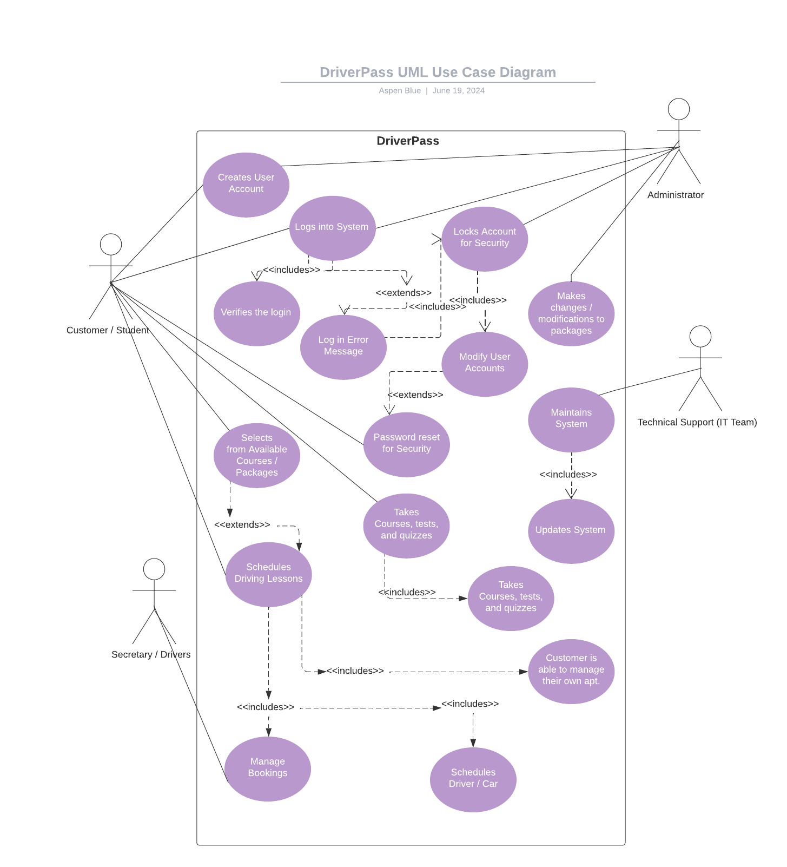

### UML Activity Diagrams

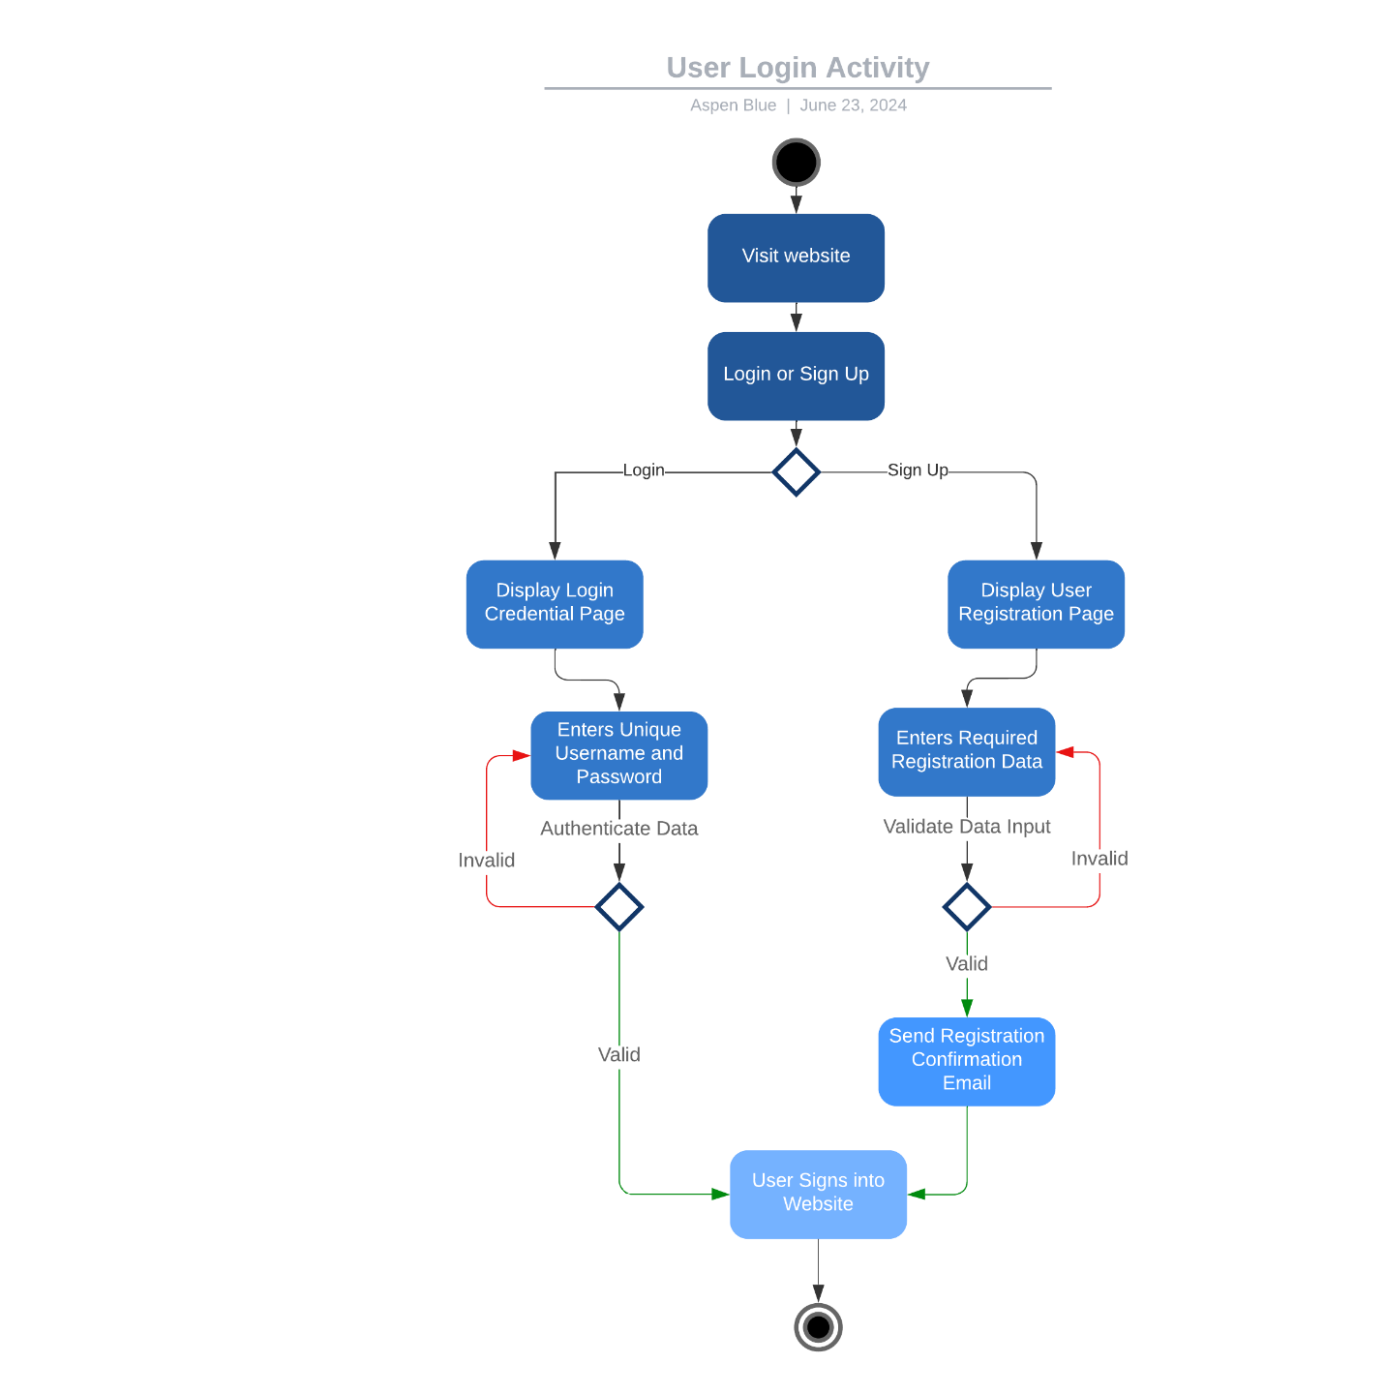

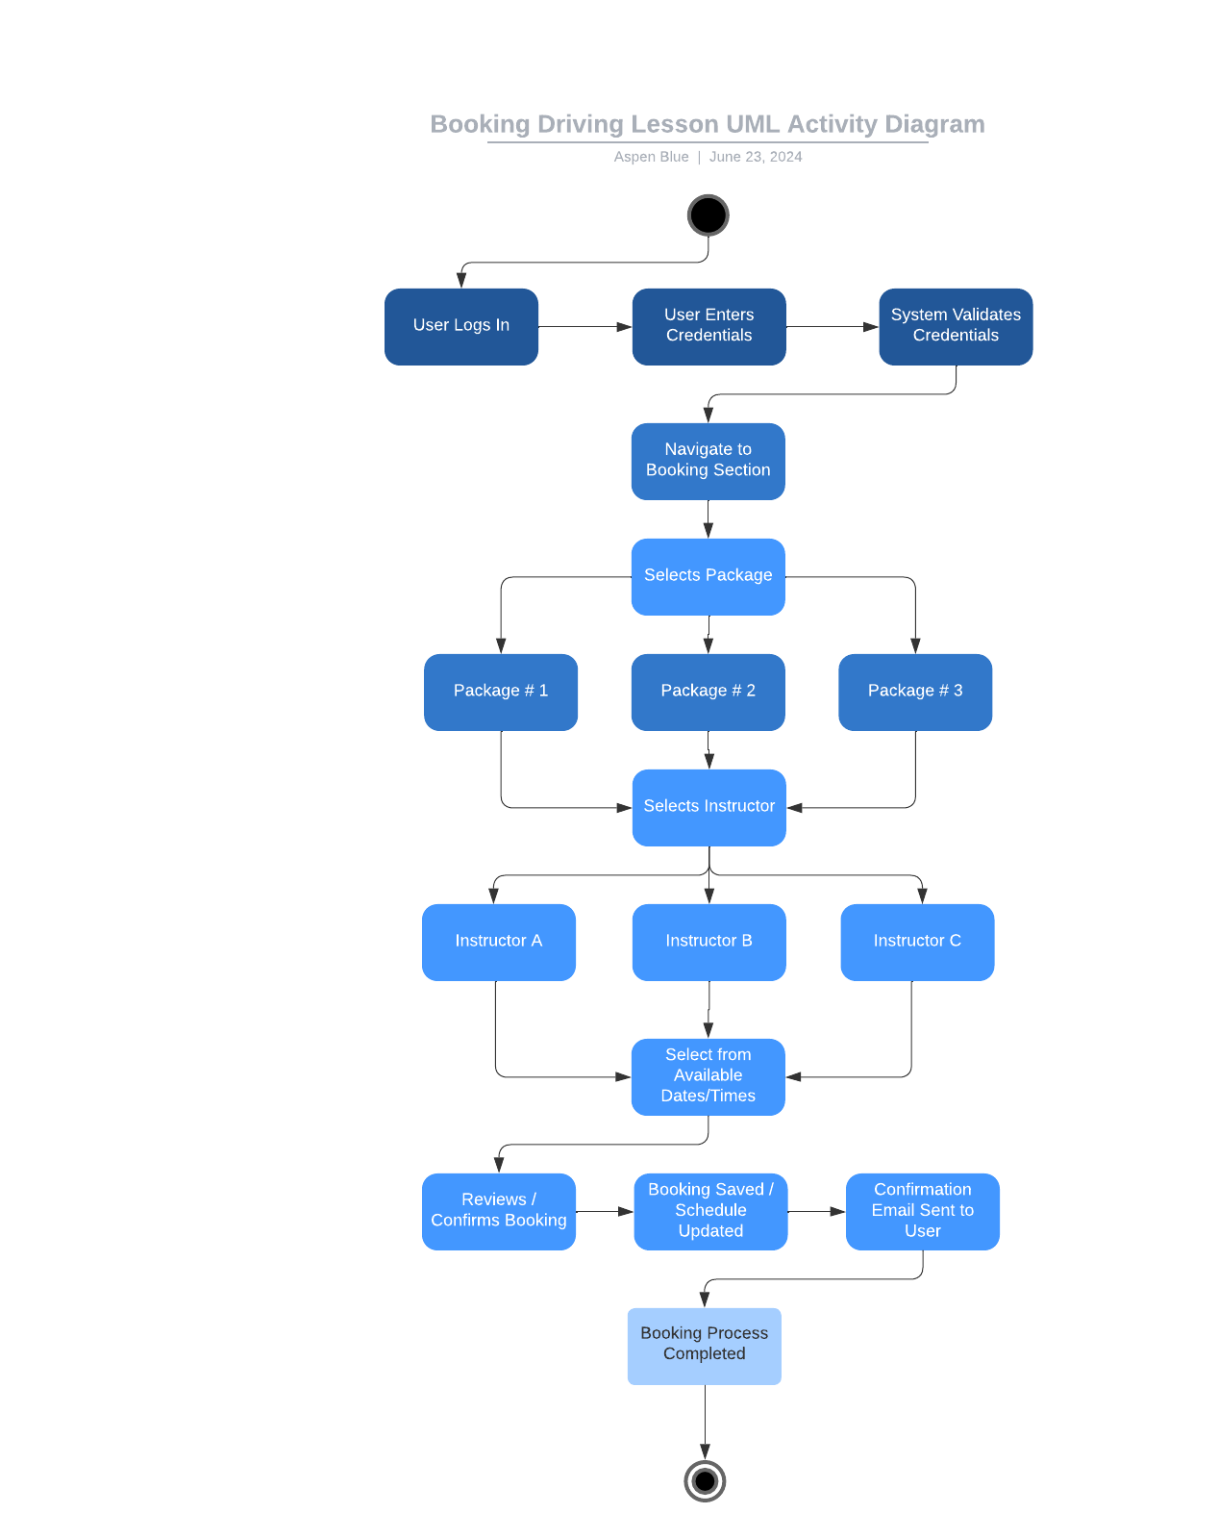

### UML Sequence Diagram

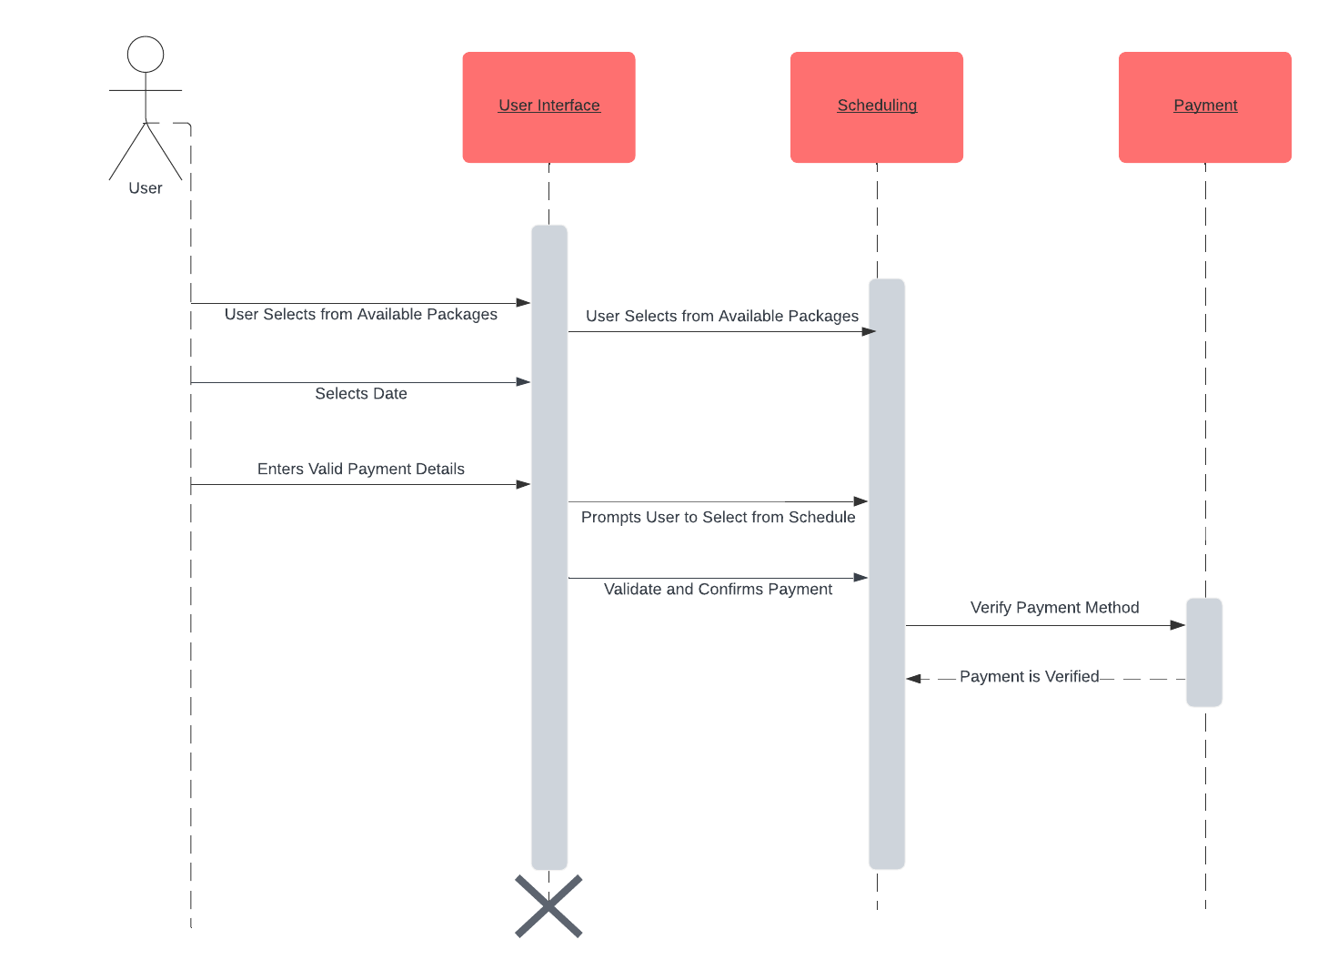

### UML Class Diagram

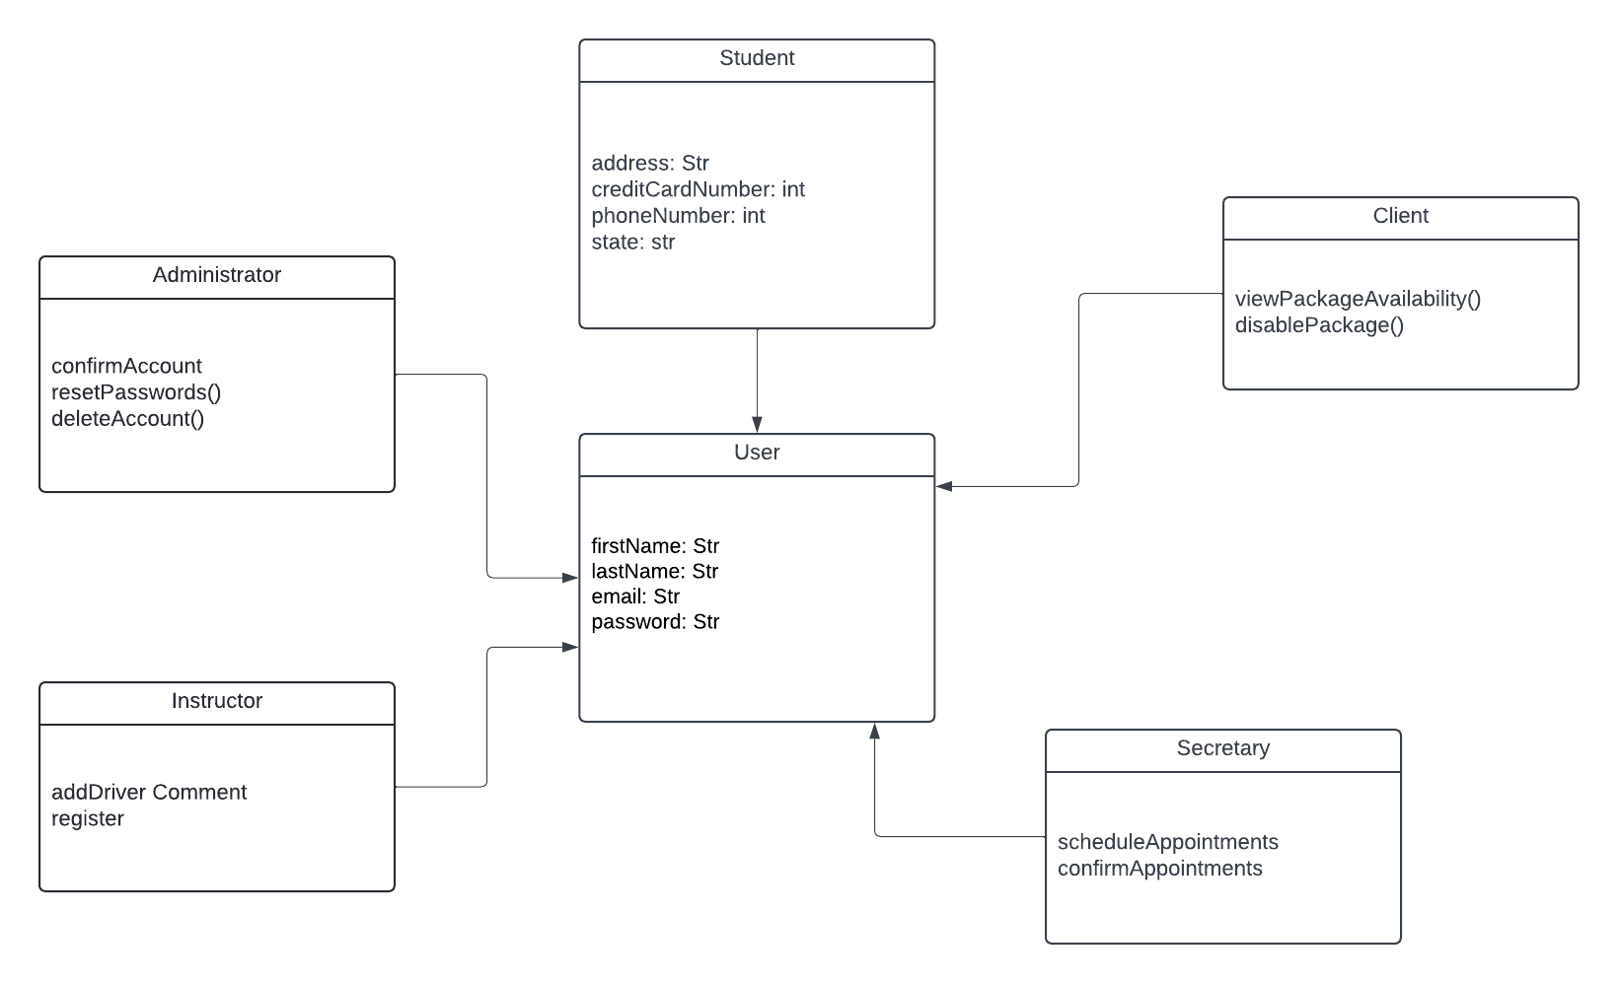

## Technical Requirements

The DriverPass system requires high-performance servers with multi-core processors, ample RAM, and fast storage. Users need modern devices with reliable internet. The system runs on Linux, Windows Server for the backend, and various operating systems for user devices. A robust database system, security software, version control systems, IDEs, and CI/CD tools are essential. The infrastructure leverages cloud services for scalable hosting and a secure network. Comprehensive security measures include firewalls, IDS, and IPS. The architecture allows independent scaling, and backup solutions are in place for data recovery. These requirements aim to create a robust and scalable system for a seamless, secure, and efficient user experience.